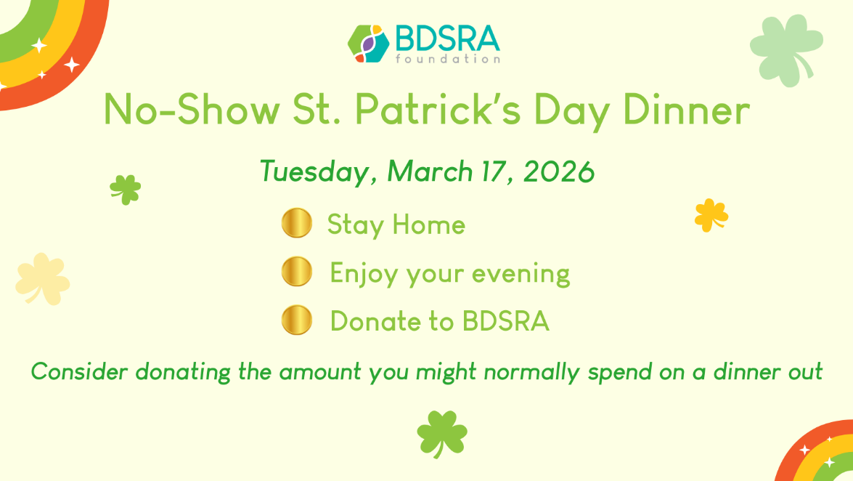
Subject Line: The Easiest Way to Celebrate St. Patrick’s Day — and Make a Difference 🍀
Dear Friend,
This St. Patrick’s Day, we invite you to participate in one of the simplest and most enjoyable fundraisers you’ll ever attend — because you don’t have to attend at all.
Our No-Show St. Patrick’s Day Dinner supports the important work of the BDSRA Foundation.
Instead of purchasing a ticket for an event, we invite you to stay home, enjoy your evening, and consider donating an amount equal to what you might normally spend on dinner out.
Your gift helps ensure that we can continue providing support services to children and adults affected by Batten disease and their families, who rely on us every day.
Imagine the impact we can make together:
🍀 $50 – “Dinner Guest”
Helps cover expenses related to our Annual Family Conference in Chicago, July 9-12, 2026
🍀 $100 – “Lucky Table Host”
Helps expand critical programs that support our affected children and their families.
🍀 $250+ – “Pot of Gold Supporter”
Makes a lasting difference in the lives of those who depend on our work.
Participating is easy:
- Stay home on March 17.
- Enjoy dinner wherever you like.
- Donate to support the BDSRA Foundation: https://web.charityengine.net/St.PatricksDayBDSRA/
No parking.
No speeches.
No dishes.
Just the satisfaction of knowing you helped and honored children, adults (including our brave Batten leprechaun), and their families affected by Batten disease as they courageously battle this terrible disease each day.
Thank you for being part of our community and helping us turn a simple idea into meaningful change.
With much gratitude,
(name of parent, community member, research or support partner, etc.)
The BDSRA Foundation is a nonprofit 501(3)(c) organization. For additional information on the organization and its life-changing mission, please visit bdsrafoundation.org. Thanks again!

